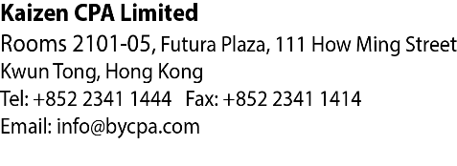

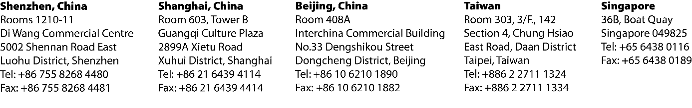

Hong Kong Company
Procedures and Fees for Restoration (by Court Order)

The restoration procedures described in this quotation apply to restoration of a company deregistered voluntarily by its members or directors of a company. If the company to be restored (reinstated) was struck off by the Registrar of Companies because of the failure to file annual returns, please refer to our quotation for restoration by Administrative Procedure “Hong Kong Company - Procedures and Fees for Administrative Restoration”.

Summary

In the case where a company has been deregistered and is dissolved, under section 291AA of the predecessor Ordinance (previous Company Ordinance, Cap. 32) or under section 750 of the current Ordinance (Companies Ordinance, Cap. 622), that is, the company has been deregistered voluntarily by itself, an application may be made to the Hong Kong High Court under section 765 of the current Ordinance by the company, a shareholder or a creditor of the company or a person who fees aggrieved by the deregistration, for an Order that the company be restored to the Register.

Kaizen's charges for carrying out all of the preparation work (including obtaining relevant letters and collating documentation, drafting the application, affidavit and Order, filing the application and dealing with advertisement) are HKD36,800. This includes our professional service fee and fees to be paid to our partner lawyer for handling the court application.

Normally, the application for court order for restoration of a deregistered Hong Kong company would take anywhere from 4 to 6 months.

1. Costs for Reinstatement

(1) Fees for Reinstatement

Kaizen's charges for carrying out all of the preparation work (including obtaining relevant letters and collating documentation, drafting the application, affidavit and Order, filing the application and dealing with advertisement) are HKD36,800. This fee, however, is subject to change depending on whether the Court would require additional evidence, a hearing or other steps/conditions to be complied with.

Our restoration services include advising client as to whether administrative restoration is available or if reinstatement by court order is the only option in the circumstances, the total costs involved, and whether any other course of action, such as just setting up a new company, is available.

In particular, our restoration services include:
- Review the filing history of the company
- advice as to the procedures and issues involved
- Deal with the High Court in respect of the application for restoration
- preparation of outstanding annual returns and renewal of business registration certificates
- the application to the Companies Registry
- checking and submitting all required documents

(2) Company Secretary and Registered Office

After the company is reinstated, it is required to maintain a registered office in Hong Kong and also maintain a company secretary. Kaizen can provide the registered office and act as company secretary for a fee of HKD2,000 and HKD3,200 per annum respectively.

(3) Other Costs

The fees mentioned above do not include the fees to be paid to the Hong Kong Government for filing of the Annual Returns and renewal of business registration certificates for the period from the date the company was deregistered till the time of application for reinstatement. Once we are being engaged for handling the reinstatement, we will perform a complete company search with the Companies Registry, the Inland Revenue Department and the Business Registration Office to find out all outstanding filings and returns. By then, a more accurate estimate of the total costs can be advised.

2. Conditions for Reinstatement by Court Order

(1) The court may order that the Registrar reinstate the registration of a company that was deregistered under section 291AA of the predecessor Ordinance if an application for reinstatement is made to the court within 20 years of the deregistration and the court is satisfied that it is just that the registration of the company be reinstated.

(2) During the course of application for reinstatement, the company or the applicant is required to file all outstanding Annual Returns from the day when the company was deregistered to the time of application for reinstatement, as if the company has never been deregistered pay all Annual Return statutory filing fees together with late filing penalty, if any.

(3) In addition, the company or the applicant is required to renew the business registration certificate from the day when the company was deregistered to the time of application for reinstatement, as if the company has never been deregistered.

3. Procedures for Reinstatement by Court Order

(1) An application for restoration is made to the court. The application must be supported by an affidavit sworn by an authorised representative of the applicant.

(2) The application, sworn affidavit and draft Order are filed with the Court.

(3) Upon receipt of the written application, the Court will send a request to the Companies Registry to confirm if the Registrar would object to the reinstatement application;

(4) Then, the Registrar will send a letter to the Lawyers directing to pay the costs for giving their consent to Originating summons. The Registry will require the filing of all outstanding annual returns, confirm to the Registry as to who will act as the director and secretary upon restoration and to where the registered office will now be located; after all outstanding annual returns are filed, the Registrar will write to the Court to confirm that he has no objection to the reinstatement application.

(5) Usually, the Court will determine the application on paper without the need for a hearing. If the Court is satisfied with the application and the evidence as filed, the Order will be made confirming the restoration subject to the conditions that the fees are paid as stated in the Registrar's letter and that a notice of the new registered office is filed with the Companies Registry.

(6) If the Court is not satisfied with the application, it may order that further evidence be filed, that the application be served on the Registrar of Companies, that an oral hearing take place before a judge or he may dismiss the application.

(7) Once the Order is made, it has to be advertised in the Hong Kong Government Gazette. It normally takes three weeks to publish the same in the Gazette.

4. Timeframe

The Court will usually consider and determine an application within four weeks of it being filed. However, time will be required to be allowed for the following:
(1) obtaining the letter(s) of no objection from the Registrar of Companies;
(2) collating the relevant documents that must be exhibited to the affidavit; and
(3) having the affidavit sworn, particularly if the deponent is a person overseas. (The original affidavit must be filed with the application).

In general, it will take around 4 months to reinstate a company to the Register of Companies.

If the Court does not grant the Order on the application and requires further evidence, service on the Registrar or a hearing before a judge, the timeframe will be extended depending on what is required.

Normally, the application for court order for restoration of a deregistered Hong Kong company would take anywhere from 4 to 6 months.

If you wish to obtain more information or assistance, please visit the official website of Kaizen CPA Limited at www.bycpa.com or contact us through the following and talk to our professionals:
Email: info@bycpa.com, enquiries@bycpa.com
Tel: +852 2341 1444
WhatsApp/Line/Wechat: +852 6114 9414, +86 1521 932 644

